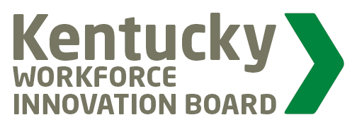
KWIB
Workforce Participation Committee
Meeting

AGENDA
June 3, 2019 @ 9:00 am

Sower Building - Frankfort, KY

- Call Meeting to Order / Introductions

- Populations and Metrics Discussion

- Essential Skill Certificates – How it Helps Workforce Participation

- KY Works Collaborative Updates

- KHIPP – Think Tank Planning

- Next Meeting…

