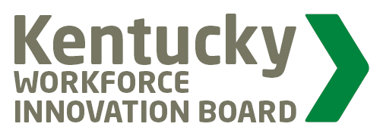
KWIB
Workforce Participation Committee
Meeting

AGENDA
March 25, 2019 @ 9:00 am

Sower Building - Frankfort, KY

- Call Meeting to Order

- Welcome and Introductions

- Kentucky Health Update

- Opioid Crisis – A Kentucky Transformation

- Opportunity Youth: FRYSCs – Who Are They and How Can They Help?

- Regional Workforce Participation Sessions

- Ky Works Collaborative Update

- Next Steps…

