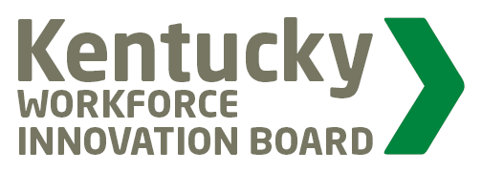
KWIB
Joint Committee Meeting of
Education Attainment and Completion
and
Employer Engagement

AGENDA
April 18, 2019
1:30 – 3:00 pm

Sower Building - Frankfort

- Call Meeting to Order

- Welcome and Introductions

- Perkins Leadership Funds ReCap

- CTE Certifications Review for 2019/2020 School Year

- Discussion of Annual Review of CTE Certifications

- “Taking a Chance” - Organic Grassroots

- WorkBased Learning – How Do We Grow Kentucky?

- Other

- Adjourn

